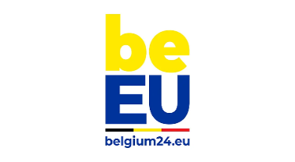
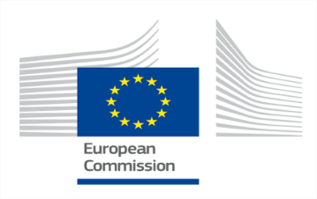
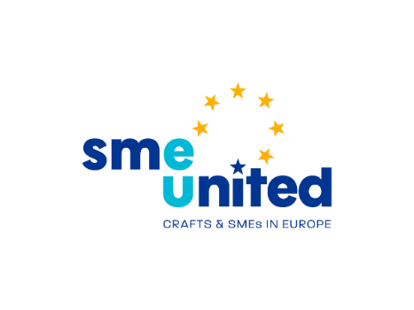

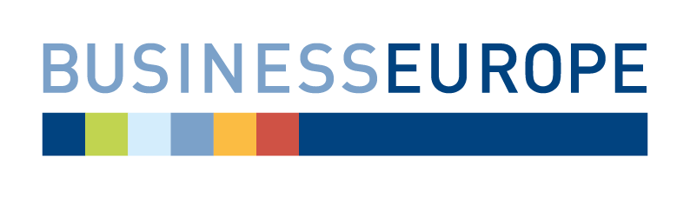
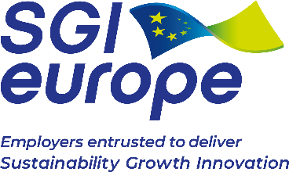
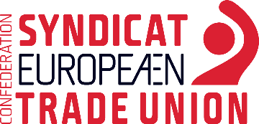

Val Duchesse Social Partner Summit
Tripartite Declaration for a Thriving European Social Dialogue
‘Pour que l'Union européenne fonctionne, il faut la compétition qui stimule, la solidarité qui unit et la coopération qui renforce.’ (Jacques Delors)
On this day, 39 years ago, the Val Duchesse Summit marked a historical moment. It laid the foundations for the involvement of the European social partners in EU policymaking. This forged the way to how EU social policies are shaped today and developed the European Single Market.
Recent crises have had a considerable impact on the cost of living and on the competitiveness of our businesses, testing the resilience of our citizens and companies alike. The EU has taken prompt and decisive measures to mitigate the impact of these crises on our economies and societies, while maintaining its ambitious green, digital and social agenda. Building on these, the full implementation of the European Pillar of Social Rights, the future of the Single Market and European competitiveness will be at the heart of the reflections on the Union’s priorities for the next years.
To meet the common goals we have set for ourselves, an effective Social Dialogue at EU level is and remains essential. Enshrined in the Treaty on the Functioning of the European Union, European social dialogue at all levels is brought to life via consultations, discussions, negotiations, agreements and joint actions. It is a fundamental component of the European social model and of our European democracy. It improves working conditions and contributes to make the EU the best place to live, work and do business.
This Declaration represents a renewed commitment to strengthen social dialogue at EU level and to join forces in addressing the key challenges our economies and labour markets are facing. The objective is to achieve thriving companies of all sizes, services of general interest and public services, quality jobs and improved working conditions.
As part of this commitment to reinforcing and embedding social dialogue in EU policymaking, the European Commission, the Council, and the European Social Partners commit to undertake the following:
Addressing labour and skills shortages
Labour and skills shortages appearing in many sectors have become a bottleneck for sustainable growth. The EU’s future long-term competitiveness needs to go hand in hand with quality jobs and a workforce that is equipped with the right skills. The right to quality and inclusive education, training and lifelong learning as set out in Principle 1 of the European Pillar of Social Rights is essential to help all working, unemployed and inactive people.
Building on policy measures put in place by the EU and its Member States, the signatories are committed to each do their part to bring more people to the labour market, improve working conditions, facilitate the recognition of qualifications and integrate workers coming from abroad, through social dialogue and collective bargaining.
The Commission, in cooperation with social partners, will come forward with an Action Plan to address labour and skills shortages, by spring 2024.
Putting European social dialogue at the heart of our future
The signatories reiterate their commitment to fully respect and promote the role of social partners and bipartite social dialogue. This includes the full respect for the prerogatives of trade unions and employers’ organisations as the actors for social dialogue and for the unique role that social partners and social dialogue have at the European and national level. The role that the Treaty awards to social partners differentiates social dialogue from other forms of consultation, such as the dialogue with civil society.

Establishing a European Social Dialogue Envoy
In order to promote and strengthen the role of social dialogue at European and national level, a dedicated European Social Dialogue Envoy will be established within the European Commission. The Envoy will support and coordinate the implementation of the Commission Communication on strengthening social dialogue in the EU, building on the Commission’s network of social dialogue coordinators, and will be the contact point for social partners to jointly inform about concerns related to social dialogue.
To that end, the Commission will establish, in consultation with the European Social Partners, a mechanism to receive joint reports from the European Social Partners on social dialogue at EU level. In circumstances where social partners jointly identify that social dialogue is not being respected and appropriately promoted at EU level, the Envoy will follow-up and coordinate the response to be given by the Commission to these joint reports.
Where social partners jointly identify concerns at national level, the Envoy will channel these joint concerns to the EU institutions.
The European Social Dialogue Envoy will liaise regularly with the European Social Partners. The Envoy should act impartially and in line with the Commission’s institutional prerogatives, and fully respect the autonomy of the European Social Partners, who will continue to engage directly - individually or jointly - with the EU institutions as part of EU policy and social dialogue processes.
The Envoy will contribute to the implementation of the commitments taken to support and promote social dialogue, including in the quadripartite statement “A New Start for Social Dialogue”.
Launching a Pact for European Social Dialogue
This Val Duchesse Social Partner Summit initiates a process towards a “Pact for European Social Dialogue”. A series of tripartite and bipartite meetings with the European Social partners will be undertaken to identify new proposals to reinforce European Social Dialogue.
The meetings will address, amongst others, the EU institutional and financial support for European social dialogue at all levels, the capacity building of social partners, including through the use of ESF+, and of social partners in candidate countries, an agreed bipartite approach on the negotiation processes and the implementation and promotion of European autonomous agreements and agreements implemented via European Directive/Council Decision.
The outcome of this process will be a “Pact for European Social Dialogue” with the aim to conclude by early 2025.

The undersigned,

Done at the Val Duchesse Social Partner Summit, 31 January 2024, in two original copies in the English language.

FOR THE EUROPEAN COMMISSION  Ursula von der LEYEN  President of the European Commission |  | FOR THE BELGIAN PRESIDENCY OF THE COUNCIL OF THE EUROPEAN UNION  Alexander DE CROO  Prime Minister of Belgium
FOR BUSINESSEUROPE  Fredrik PERSSON  President of BusinessEurope |  | FOR ETUC  Esther LYNCH  General Secretary of ETUC
FOR SGI EUROPE  Pascal BOLO  President of SGI Europe |  | FOR SMEUNITED  Petri SALMINEN  President of SMEunited

