Press release 2 April 2015
Monaco Trade Mission to Prague - 8/10 April 2015
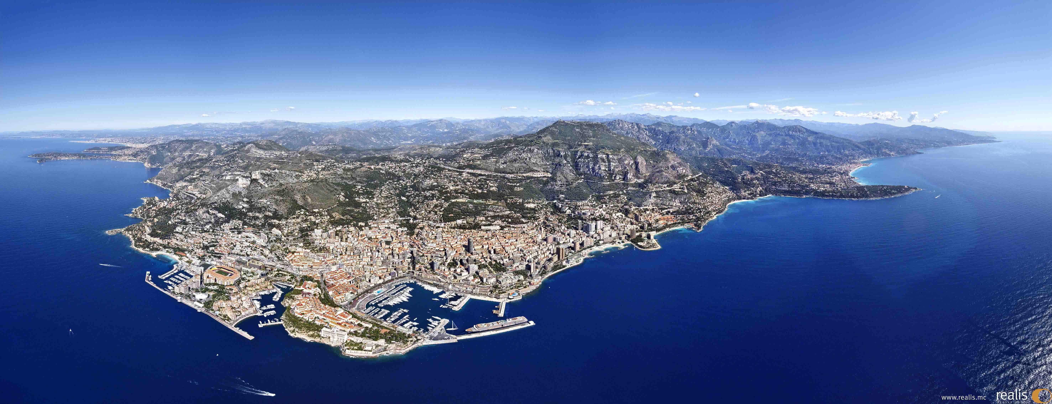

The Principality of Monaco
is coming to Prague to promote its business activities

Famous for its F1 Grand Prix and casinos, the Principality of Monaco is less well known from a business angle. And yet this country which covers just 2 km2 is amazingly dynamic with a GDP per capita that is one of the highest in the world. It is to promote a better understanding of this commercial force that the Monaco Chamber of Economic Development (CDE) and 25 companies from the Principality will be in Prague on a trade mission on 8 and 9 April as part of a State Visit by HSH Prince Albert II to the Czech Republic.

For CDE Chairman Michel Dotta: “The Czech Republic represents an excellent platform for Monaco companies keen to develop their activities in the Central and Eastern European countries. In turn the Principality of Monaco offers one to Czech companies who want to extend their influence in the Mediterranean basin and Africa.”

Synergies have already been identified in tourism, real estate, architecture & design, financial engineering, insurance, information and communication technologies (ICT), international trade and renewable energy, all sectors which will be represented in the Monegasque delegation in Prague.

On 9 April, the CDE and its partners, the Ministry of Trade & Industry, the Confederation of Industry, and development agency Czech Invest, are organising bilateral meetings and Business to Business meetings between Czech and Monaco companies.

Symbolic of this desire to boost trade between the two countries, the respective chairmen of the CDE and the Confederation of Industry of the Czech Republic, Michel Dotta and Jaroslav Hanák, will sign the same day a partnership agreement at the Ministry of Trade and Industry in the presence of HSH the Sovereign Prince of Monaco and Czech Deputy Minister of Trade and Industry, Mr Vladimir Bärtl.

The agreement will establish a permanent collaboration between Monaco and the Czech Republic where trade links already exist, notably in Zebrak where one of the Principality’s key industries - the car parts manufacturer Mecaplast - has a production plant, but which are ripe for further development.

This trade mission is the latest in a number of initiatives taken by the CDE and its Czech counterpart over several years to boost trade between the two countries, starting in 2008 with a CDE trade mission to Prague, then an Ambassador’s Lunch held in Monaco in 2009 and more recently in 2014 a trade mission of Czech companies to the Principality led by H.E. Mrs Marie Chatardova, the Czech Republic’s Ambassador in Monaco.

Media contact: Dany RUBRECHT – Tel +377 97 98 68 68 or +33 6 80 86 36 51 – drubrecht@cde.mc

Appendix 1 : list of companies and entities from Monaco attending the Monaco Trade Mission to Prague
Appendix 2 : the Monaco Chamber of Economic Development (CDE) and Monaco’s key economic facts and figures

Smallest in the world after the Vatican
€64,000

