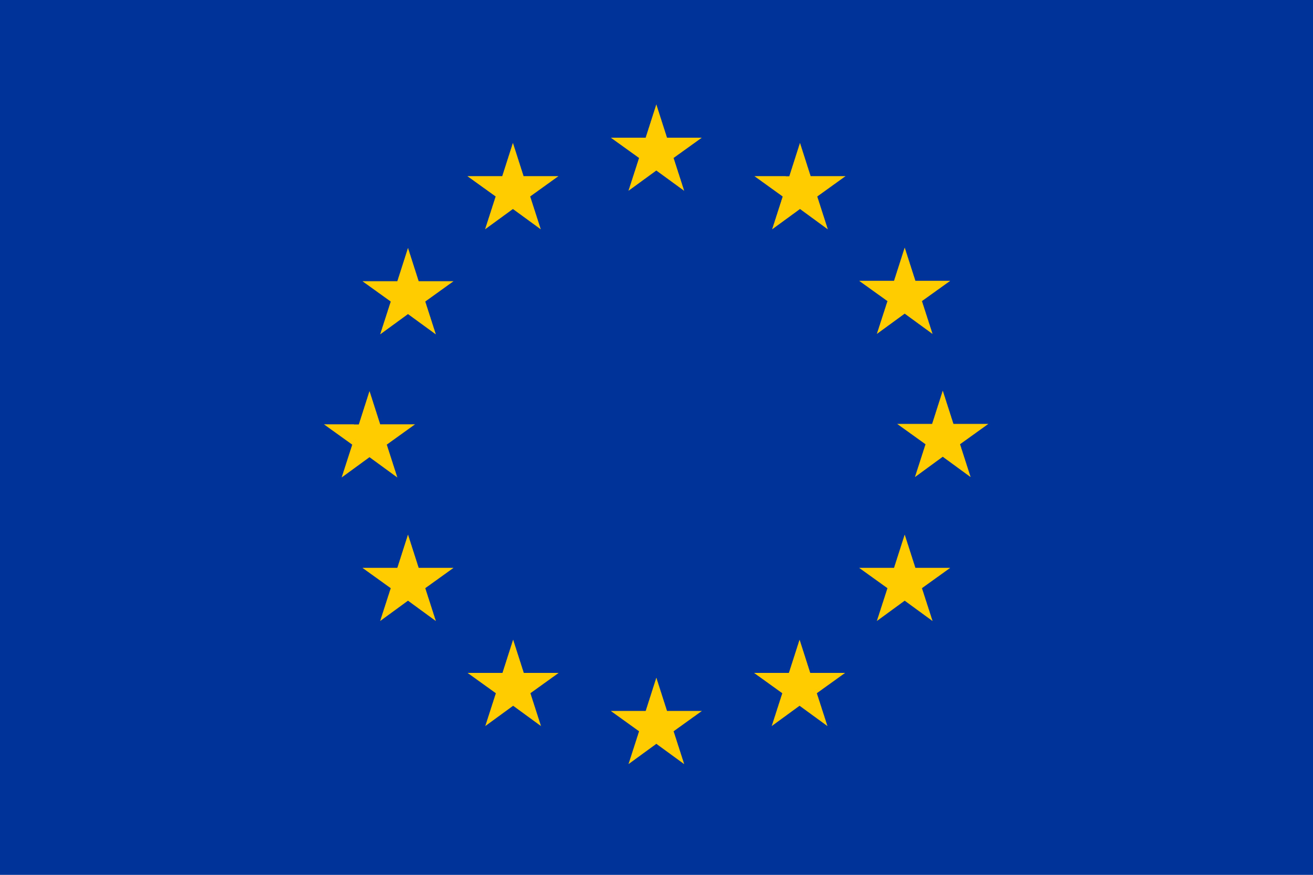
Conference on Trade and Business Opportunities in Jordan
Implementing the EU-Jordan Agreement on the simplification of the EU rules of origin
Brussels, 25/01/2017
Berlaymont, European Commission
Conference (Morning session)
Registration  Modeartor  Emmanuel Noutary, President of ANIMA Investment Network.  Welcome Speeches  - M. Johannes Hahn, EU Commissioner for Neighbourhood Policy and Enlargement Negotiations.  - H.E. Eng. Yarub Qudah, Minister of Industry, Trade and Supply, Hashemite Kingdom of Jordan.  The situation and challenges in Jordan  - H.E. Andrea Fontana, EU Ambassador, Jordan  - Mr. Stefano Severe, UNCHR country representative, Jordan  Main features of the Simplified Rules of Origin Agreement  - Mr. Ignacio Garcia Bercero, European Commission-DG TRADE  - …, European Commission-DG TAXUD TBD  Implementation in Jordan of the Simplified Rules of Origin Agreement  - …, Ministry of Industry, Trade and Supply – Jordan TBD  Investment Climate and Incentives in Jordan.  - …, Jordan Investment Commission TBD  Industrial Sector in Jordan and Export Potential to the EU Market.  - …, Jordan Chamber of Industry TBD  Coffee Break  Panel discussion I: Donors and IFIs support to foster resilience in Jordan; followed by Q&A  Modeartor  …, EU Commission-DG NEAR TBD  - Mr. John Speakman Practice Manager for Africa, Trade & Competitiveness, the World Bank Group  - European Investment Bank TBD  - European Bank for Reconstruction and Development TBD  - Jordan Private sector representative TBD  - …, Multilateral Investment Guarantee Agency TBD  Panel discussion II: Success factors for enhancing EU-Jordan trade and investment; followed by Q&A  Modeartor  Mr. Ignacio Garcia Bercero, EU Commission-DG TRADE  - Jordan Investment Commission TBD  - EU private sector rep TBD  - Dr. Ruba Jaradat, Regional Director for Arab States  - OXFAM TBD  Closing Remarks  - …, EU Commission-European External Action Service TBD  - H.E. Mr. Mr BATAINEH Yousef, Jordanian Ambassador to the EU | 08h30-09h00  09h00-09h15  9h15-9h30  09h30-10h00  10h00-10h15  10h15-10h30  10h30-10h50  10h50-11h10  11h10-11h50  11h50-12h30  12h30-12h50

Lunch Break  The Berlaymont, (Room TBD) | 13h00-14h30
Business-to-Business Meetings (Afternoon session)
Welcome Note  - Representative from the European Union TBD  - M. Arnaldo Abruzzini, CEO, EUROCHAMBERS TBC  - Jordanian Chamber of Commerce TBD  Business-to-Business Meetings  Rotating meetings according to the agenda of each confirmed participating company with support of the EUROMED Invest Help Desk  Closing and Evaluation of Meetings  - Monica Airoldi, EUROMED Invest project | 14h30-15h00  15h00-17h00  17h00-17h30

Press Conference  The Berlaymont, (room TBD) | 17h15- 18h00
Registration
Online registration at the following link.

