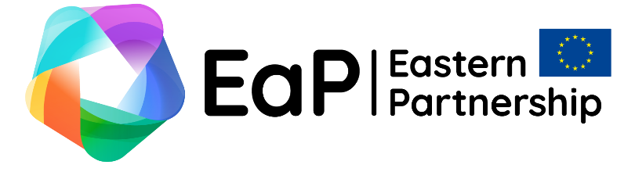

Eastern Partnership Connectivity Seminar
19 October 2022, Vilnius

Concept Paper
Exploring the potential of EU’s Global Gateway and other connectivity platforms for Easter Partnership countries and beyond
Purpose:
With this background paper, we want to set the context regarding the Eastern Partnership (EaP) Connectivity Seminar.

Event location and scope:
Event will take place 19 October 2022 in Vilnius, Lithuania. Representatives from the European Union, Eastern Partnership states and EU strategic partners Japan and the United States will be invited to attend. The main focus will be on the opportunities provided by the Global Gateway program of the EU and other regional connectivity platforms, notably such as the Three Seas Initiative (3SI).

Political context
The European Commission and the EU High Representative have launched the Global Gateway, as the new European strategy set to boost smart, clean and secure links in digital, energy and transport sectors, as well as to strengthen health, education and research systems across the world. The EU is stepping up its offer to its partners with major investments in infrastructure development globally. Between 2021 and 2027, Team Europe, meaning the EU institutions and EU Member States jointly, will mobilise up to EUR 300 billion of investments in the areas of:
- digital
- climate and energy
- transport
- health
- education and research.
Given current geopolitical context, when East/West connections and supply chains are undergoing major and long lasting disruption because of Russia’s aggression against Ukraine, the Global Gateway is poised to become an initiative of crucial importance, because it promotes worldwide infrastructure investments that create sustainable, smart, resilient, inclusive and safe networks in all key connectivity sectors. For example, it will enhance support on the extension of the Trans European Transport and Energy Networks (TEN-T) to EaP countries.
The Global Gateway stands for sustainable and trusted connections that work for people and the planet. It helps to tackle the most pressing global challenges from fighting climate change, to improving health systems, boosting competitiveness and security of global supply chains.
The Global Gateway delivers sustainable and high-quality projects, taking into account the needs of partner countries and ensuring lasting benefits for local communities. This allows EU’s partners not only to develop their societies and economies, but also creates opportunities for the EU Member States’ private sector to invest and remain competitive, whilst ensuring the highest environmental and labour standards, as well as sound financial management.
The Global Gateway serves as the EU contribution in narrowing global investment gap worldwide. It is in line with the commitment of the G7 leaders from June 2021 to launch a values-driven, high standard and transparent infrastructure partnership to meet global infrastructure development needs. The Global Gateway is also fully aligned with the UN Agenda 2030 and its Sustainable Development Goals (SDGs), as well as the Paris Agreement.
Japan is a key partner and proactive advocate of global connectivity initiatives. The EU Global Gateway context and the joint framework provided by the G7 “Build Back Better” World initiative helps the EU and Japan achieving their normative approach to connectivity standards globally. The EU-Japan Joint Study on Connectivity Cooperation in the Western Balkans, Eastern Partnership countries and Central Asia of November 2021, examines in detail the areas of potential cooperation within EU Global Gateway framework. Among them, such as “Peace Routes”, “Green Energy Corridors” or “EU-Japan Digital Trust”.
Other connectivity platforms, of more regional nature, such as the 3SI, also play an important role in matching intra-European connectivity efforts with the aim of improving connectivity and infrastructure in the neighbouring countries willing to do so. The United States have been strong supporter of the 3SI from its start and share most of its priorities. 3SI seeks to better connect the Adriatic, Baltic and Black Sea regions’ countries by strengthening cooperation and connectivity in the fields of energy security, transport infrastructure and the modern digital agenda, and by intensifying the development of the North-South transport corridor. The 3SI aims to close the remaining infrastructure gaps in the 3SI region and the development gap between the 3SI region and Western part of the EU, thus completing the transformation of Central Europe, overcoming the post-Soviet legacy in this part of Europe. 3SI is open to expand its cooperation with the Eastern Partnership countries that adhere to the same democratic values, European and transatlantic goals and common interests, thus bringing those regions closer to the European Union by increasing infrastructure interconnections.

Steering questions for the discussion at the EaP Connectivity seminar on 19 October 2022:
We invite all participants of the EaP Connectivity seminar to contribute, from their respective national perspective, to the discussion in an effective and focused manner:
- What would be the main benefits of EU Global Gateway’s connectivity for the EaP countries? What EaP flagship projects in all the main areas of connectivity are of particular importance to your country? What else should be taken into account? How strategic EU partners such as Japan, could take part in them making cooperation mutually beneficial?
- How the EU and its Member States could and should contribute to rebuilding transport infrastructure of Ukraine post-war. Should EU contribution be within timeframe of 2021-2027 or within-and-beyond?
- What would be connectivity areas where future projects involving more than one EaP country would bring certain benefits? What indicators should be considered as of key-importance to identify progress achieved?

Registration by 30th September via online link: https://www.eap-events.eu/connectivity-panel

The Ministry of Foreign Affairs of the Republic of Lithuania
Eastern Neighbourhood Policy Department
rps@urm.lt

Source: Global Gateway | European Commission (europa.eu)

