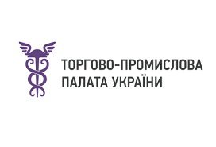 

*as of October 1, 2024*

**UKRAINIAN-CZECH BUSINESS FORUM**

**Wednesday, October 9, 2024**

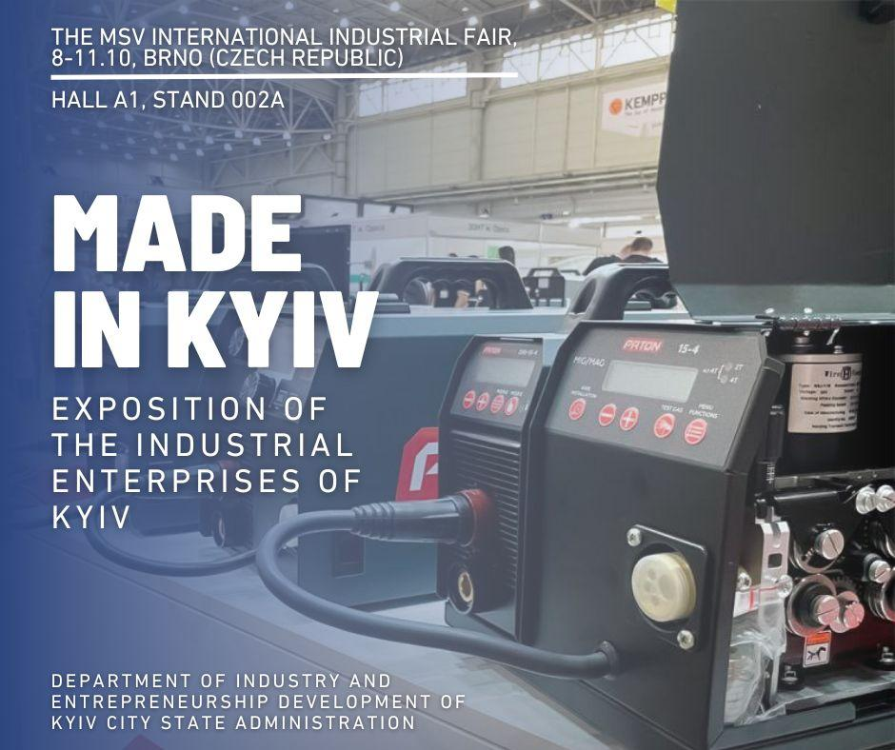

*PROGRAMME*

*Venue: Administrative building,102 room, https://www.bvv.cz/en/rental/conference-halls/room-102*

*Working languages of the forum:* Ukrainian, Czech (translation will be provided)

*Moderator:**Anna Liubyma, Director of the Department of International Cooperation at the Ukrainian CCI*

| **11:00 – 11.30** | Registration of participants |
| --- | --- |
| **PLENARY SESSION** | |
| **11.30 -13:00** | **WELCOMING SPEECHES TO THE PARTICIPANTS OF THE MEETING**   * **Mr. Vasyl Zvarych**, Ambassador of Ukraine to the Czech Republic (tbc) * **Mr. Václav Kalus,** Deputy of Government Commissioner of the Czech Republic for the Reconstruction of Ukraine * **Mr. Volodymyr Kostikov,** Director of the Department of Industry and Entrepreneurship Development, KCSA * Representative of Brno City Assembly * **Mr. Martin Pospísil**, Director of Department of European Countries Ministry of Industry and Trade of the Czech Republic * **Mr. Jakub Weimann,** Head of the working group for Ukraine, Confederation of Industry of the Czech Republic * **Ms. Oksana Antonenko,** Director of CzechTrade Kyiv Ukraine * **Ms. Michaela Macharik**, Vice-Chairman of the Presidium of the Ukrainian-Czech Chamber of Commerce (UKRCHAM)   **PRESENTATIONS:**   * **Promzvyazok** * **Paton International** * **Prolog Semicor** * **UA STAL** * **Dnipro MTO** * **IRCOM-EKT** * **Plasma-Master** * **Techservice WEKO** * **Design Bureau of Control Devices** * **Institute of Engeneering Thermophysics NAS Ukraine** |
| **13.00 - 15.00** | **B2B negotiations** (translation will be provided if necessary)  10 tables   * **Promzvyazok** * **Paton International** * **Prolog Semicor** * **UA STAL** * **Dnipro MTO** * **IRCOM-EKT** * **Plasma-Master** * **Techservice WEKO** * **Design Bureau of Control Devices** * **Institute of Engeneering Thermophysics NAS Ukraine** |