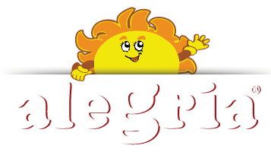
ALEGRIA LTD

- General Information

Alegria was established in 2011 and has grown day by day in the Albanian market becoming one of the best brands in the Albanian market of dried fruits and spices.
The passion of the creators of this brand and the great responsibility to the consumer has made the best quality of dried fruits and legumes under the name Alegria selected and packaged.
In recent years the company has been focused on the production and marketing of traditional Albanian products such as breadcrumbs, jufka, roshnica, raiment, trahana etc.
MISSION
Always stay close to our customers to identify and satisfy their needs, selecting our products through technologies and experiences from successful food crops around the world.
To build a Premium brand in Albania by taking care of our customers and customers by providing absolutely quality and healthy products.

- Producs

- Wheat

Ground Cinnamon

Trahana

Red Blueberry

Arabic Dates

Dried Figs

Dried Plums

Jufka

Dried Apricots

- Contacts
General Manager: Gezim Sheme
Address: Head Office: “Ana Komena” Street, Titana , Albania
Production Factory: Gjirokaster- Tepelen Naciona Road, km 13, Picar, Gjirokaster, Albania
Phone: +355 68 405 8424
E-mail: info@alegria.com.al
sales@alegria.com.al
Website: https://alegria.com.al/

The company is interested in finding buyers in Czech market and also in cooperating with the Czech companies.

