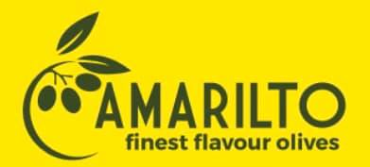
AMARILTO LTD

- General Information

Amarilto Ltd started in 1992 as a family business focused on canned olive oils and has come to offer high quality customer oriented products. Our company is today a leader in the Albanian olive industry. It is also the first olive oil company in Albania operating with a modern technology.
We produce all kinds of industrial olives for markets as well as raw materials for industry. Our focus is on preserving food quality and safety through our innovative processing, storage and packaging methods, all in accordance with international standards and regulations. Exports make up 95% of our sales, making AMARILTO LTD an international company, presenting our products in several countries around the world. We provide flexible custom solutions to our customers, listening to their needs to help them maximize their sales.

- Products
Made in Albania!
Green whole Olives.
Green pitted Olives.
Green Olives stuffed with Almond.
Green Olives stuffed with Garlic.
Green Olives stuffed with Red Pepper.
Green Olives stuffed with Hot Pepper.
Black olives .
Black pitted Olives.
Kalamata whole Olives.

International quality award in Spain.
Amarilto Ltd is decorated by the Global Trade Leaders Club with an international award for International Food & Beverages Quality Award. Amarilto's selection was conducted among 7,500 companies in 90 countries around the world.

The company is exporting in: Itali, Zvicer, Ukraine, Macedoni,Gjermani and Kosove.
Green olive
Green olives Pitted
Black olive
Black olives Pitted

- Contacts

CEO: Tom Malshi
Address: Pllane, Zejmen, Lezhe, Albania

Tel: +355682072398

The company is interested in finding buyers in Czech market and also in cooperating with the Czech companies.

