ELECTROPUTERE

Power Provider

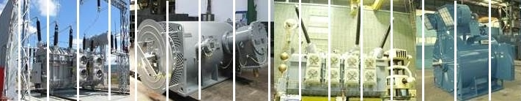

66 years of experience

Dear Madam/Sir,
Please consider this letter of introduction in view of expressing our company’s interest for promoting its products and services on new markets/countries.
We kindly ask your support in establishing contacts/meetings with any potential business partner that may be interested. For additional data please visit our web-site at www.electroputere.ro or contact us at sales@electroputere.ro.
COMPANY PROFILE: ELECTROPUTERE is a well-known Romanian manufacturer of Power Transformers and Rotating Electrical Machines, founded on 1st of September 1949 in Craiova - Romania, which has since maintained its position among the world’s leading manufacturers and delivered products to clients from over 50 countries.
PRODUCTS:
Power Transformers:
- Manufacturing range - between 10 to 440 MVA and up to 420 kV for a variety of applications, such as: generation, transmission, interconnection transformers, network transformers, etc.
- Production and engineering capabilities of experienced 300 employees, which can assure a very good delivery time for partners and clients, in accordance with their needs.
Rotating Electrical Machines (Motors and Generators):
- Customized for a wide type of applications such as: cement & metallurgical industry, oil & gas, water supply and irrigation, mining, energy production in thermal and hydro power plants, railway and urban vehicles, chemical and petrochemical industry, pulp and paper, testing equipment, etc.
- Manufacturing range - between 200 KW - 7,000 KW for low and medium voltage asynchronous motors and up to 5,000 kVA for synchronous generators.
- Special motors for fire proof and exposure proof based on ATEX guidelines and certification.
SERVICE: For its own products portfolio as well as for third parties products, our company offers repairs and maintenance service and after sales services.
CERTIFICATIONS: ELECTROPUTERE is certified by ISO 9001, ISO 14001, OH SA 18001, Nuclear and ATEX and its products comply with international standards such as IEC 60076 and ANSI C57.
BUSINESS MODEL: based on partnering with companies acting as EPCs, OEMs and distributors to reach various markets and end-users and sustains opportunities of developing mutually beneficial business relationships.
Thank you in advance for your answer.
Sincerely Yours,
Toni AKIKI
Vice President-Operations
+40 743 016 778
Toni.akiki@electroputere.ro
www.electroputere.ro www.electroputere.ro www.electroputere.ro

