

**Business Opportunities in Energy and Connectivity:**

**Eastern Partnership and**

**Central Asia**

**May 18, 2021**

Via Eventtia

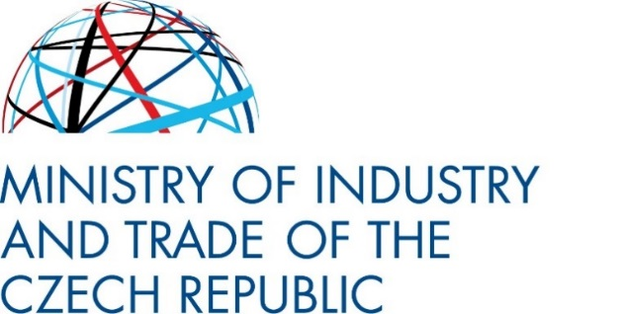****

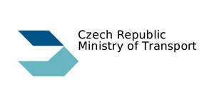

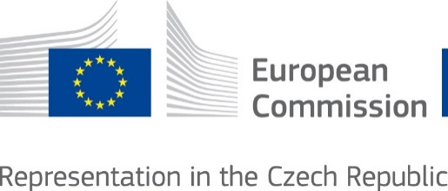****

**FACTS ABOUT THE CONFERENCE**

In recent years, the markets stretching between the European Union and East Asia have been gaining in attractivity and importance for the EU exporters and investors.

European entrepreneurs have been deepening their ties with the countries of Eastern Partnership and Central Asia not only based on close and long-term relationships, but also seeking opportunities in new trends and technologies. The eleven countries of the region present particular potential for cooperation in the current sectoral priorities identified by the European Commission in Digital Transition, Green Deal and Infrastructure Connectivity. The conference therefore aims to create space for discussion about detailed opportunities in these areas and seeks to emphasize new synergies leading to increased mutual trade and investment.

The event also builds on the Council conclusions on EU energy and climate diplomacy, a January 2021 guidance on how to reach out to our international partners and motivate them to seek opportunities in the green energy transition. The Czech Republic therefore aims to reaffirm its strong interest in the economic development of the eastern neighbourhood of the European Union and the intention to contribute to the practical implementation of these Council conclusions.

Participants will receive detailed information on trends and policies in energy and connectivity in the region. They will be able to identify opportunities for the involvement of Czech businesses in existing and planned infrastructure projects. Entrepreneurs and investors will have a unique chance to familiarize themselves with respective flagship projects and determine their business potential in the target country.

The conference follows the East-West Connectivity Forum (Prague 2018) and to the 10 Years of Eastern Partnership Conference (Prague 2019).

**SPEAKERS & PARTICIPANTS**

The conference brings together an inspiring combination of stakeholders – senior officials from the EU and the Czech Republic, 11 countries of the region (Armenia, Azerbaijan, Belarus, Georgia, Kazakhstan, Kyrgyzstan, Moldova, Tajikistan, Turkmenistan, Ukraine and Uzbekistan), state administration, business, banking sector and academia.

**FOR MORE INFORMATION CONTACT THE MINISTRY OF INDUSTRY AND TRADE OF THE CZECH REPUBLIC**

**Mr. Matyáš Viktora,** [viktora@mpo.cz](mailto:viktora@mpo.cz)

**Mr. Jakub Mareš,** [mares@mpo.cz](mailto:mares@mpo.cz)

East Europe, Western Balkans, and Central Asia Countries Division



Programme

**8:30 Opening of the Virtual Room**

**9:30 – 10:00 Introductory Remarks and Keynote Speeches**

* Deputy Prime Minister, Minister of Industry and Trade, and Minister of Transport of the Czech Republic, Mr. Karel Havlíček.
* Vice President of the Confederation of Industry of the Czech Republic, Mr. František Chaloupecký.
* EEAS: EU Special Representative for Central Asia, Mr. Peter Burian.
* DG NEAR: Head of Unit, Mr. Vassilis Maragos.

**10:00 – 11:15 Session 1: Transport connections between East and West**

* Chaired by: Deputy Minister of Transport of the Czech Republic, Mr. Jan Sechter.
* DG MOVE (TBC).
* Deputy Minister at the Ministry of Transport of the Republic of Uzbekistan, Mr. Abdusamat A. Muminov.
* Representatives of Armenia (TBC), Azerbaijan (TBC), Belarus (TBC), Georgia (TBC), Kazakhstan (TBC), Kyrgyzstan (TBC), Moldova (TBC), Tajikistan (TBC), Turkmenistan (TBC), and Ukraine (TBC).
* Guiding questions:
  + Does your country have any special projects (planned, ongoing or completed) or investments that contribute to connectivity between our regions?
    - Are there any bottlenecks on the main transport routes / connections?
    - What are the main modernization priorities in your country to improve capacity of transport network?
  + Are there specific areas where your country can offer unique value to improving connectivity between our regions?
  + What are your plans, activities and projects to modernize the transport sector, especially in terms of decarbonisation and/or digitalization?
  + How do you foresee your country could become involved in multimodal transport? What are the priorities? What are the obstacles?
  + Where do You see opportunities for our companies to be involved in your projects? Can you describe any obstacles limiting foreign companies as participants in the key projects in your countries?
  + How does your country describe a role of the EU to improve connectivity between regions?
* Discussion.

**11:25 – 12:50 Session 2: Cooperation in Energy Industry and Energy Policy**

* Chaired by: Deputy Minister of Industry and Trade of the Czech Republic, Mr. René Neděla.
* DG ENER: Ms. Marion Schiller-Probst.
* Deputy Minister at the Ministry of Foreign Affairs of the Republic of Belarus, Mr. Evgeny Shestakov.
* Deputy Director at the QazTrade agency, Mr. Nuraly Bokeikhanov.
* Head of Energy Policy and Investment Projects Department at the Ministry of Economy & Sustainable Development of Georgia, Mr. Tornike Kazarashvili.
* Head of the Renewable Energy Division at the Ministry of Energy and Natural Resources of the Republic of Armenia, Ms. Victoria Keshishyan (TBC).
* ****Representatives of Azerbaijan (TBC), Kyrgyzstan (TBC), Moldova (TBC), Tajikistan (TBC), Turkmenistan (TBC), Ukraine (TBC), and Uzbekistan (TBC).
* Guiding questions:
  + Given the worldwide changing approaches to energy policy (decarbonization / electrification / significant investment in renewable energy sources), what are your national energy policy priorities? Which source of energy will play a crucial role in your energy mix in coming years?
  + Where do you see potential for cooperation? What sectors will require significant investment in the upcoming years? What technologies / innovations can enable energy transition in your country?
* Discussion.

**12:50 – 13:00 Closing remarks**

* Deputy Minister of Industry and Trade of the Czech Republic, Ms. Martina Tauberová.

