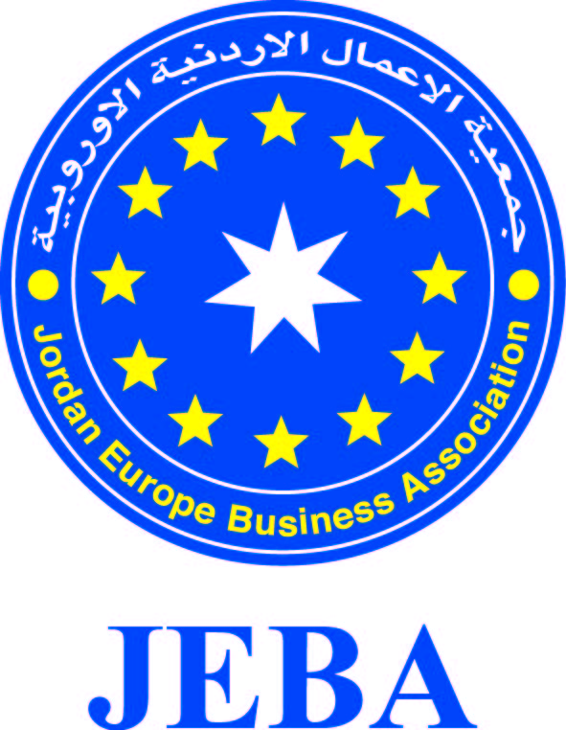

Jordanian Economic Delegation to Czech 19-21/9/2018
No | Institution Name | Contact Person | Tel | Fax | Email / Website | Sector
1 | Jordan Europe Business Association (JEBA) | Mr. Jamal M. Fariz president | +962 6 5667447  +962 795525552 | +962 6 5660988 | info@jeba.org.jo  www.jeba.org.jo | Business Services  Financial services
2 | Amman chamber of Industry | H.E. Senator Ziad Homsi  Chairman | +962 6 4643001  + 962 79 5556060 | +962 6 4647852 | aci@aci.org.jo  www.aci.org.jo | Industry
3 | Amman chamber of Commerce | Mr. Nafez Alayyan  Second Vice Chairman | +96 2 6 5666151  +962 79 5523989 | +962 6 5666155 | nafezalayyan@hotmail.com | Trade
4 | Amman chamber of Commerce | Mr. Tarek Tabbaa  Board Member | +96 2 6 5666151  +962 79 6790000 | +962 6 5666155 | tarek@al-tewfik.com.jo | Trade
5 | Taff Contracting est.  General Manager | Eng. Basem Abu Taleb  JEBA Treasurer | +962 6 5885180  +962 796611700 | +962 6 5885181 | babutaleb@taffcontracting.com | Construction, Real Estate, Renewable energy, Swimming Pool Chemicals, Furniture
6 | Arab Technical Co. for Plastic Industries  Chairman of the Board | Mr. Ahed Al Rajbi  JEBA Board Member | +962 6 4023844  +962 799960004 | +962 6 4023739 | info@top.com.jo  www.top.com.jo | Plastic Industries (Manufacturer)  Type of cooperation  Export
7 | Al Atoom Investment CO.  General Manager | Dr. Ali Al Dandan  Chairman of Jerash Chamber of Commerce | +962 776007373 |  | alidandan@seznam.cz | Real Estate, hospitality as restaurants, hotels  Type of cooperation  Import & export
8 | Jordan Europe Business Association (JEBA) | Mr. Ayman Qaffaf  General Manager | +962 6 5667447  +962 796966798 | +962 6 5660988 | info@jeba.org.jo  www.jeba.org.jo | Business Services
9 | Trust Seeds Co. | Mr. Na’el Omar Omar  Shareholder | +962 6 5522293  +962 79 5543721 | +962 6 5522279 | info@trustseeds.com  www.trustseeds.com | Plant Breeding & Seeds production
10 | Anwar al Dallah for Travel & Tourism | Mr. Bahjat Hamdan  General Manager | +962 6 5693077  +962 79 5583584 | +962 6 5659988 | bahjat_07@yahoo.com | Travel & Tourism
11 | Refadah Travel | Mr. Raid Beetar  General Manager | +962 6 5656100  +962 79 6211311 | +962 6 5658557 | raed@refadah.com  www.refadah.com | Travel & Tourism
12 | Beauty Secrets for Dead Sea Products | Mr. Abed Allah Al Banna  General Manager | +962 6 4398900  +962 795663440 | +962 6 4398901 | info@b-secrets.com  www.b-secrets.com | Cosmetics, Perfumery, Dead Sea Products (manufacturer)  Type of cooperation  Export
13 | Blachwak for Military Supplies & Aircraft – Aviocom | Mr. Khaldoun Haddad  CEO | +962 6 5561939  +962 795946809 | +962 6 5561949 | khaldoun@aviocom.net  www.aviocom.net/en | Military & Defense, Security, Aviation  Type of cooperation  Distributors, representative, wholesaler
14 | Al Sahra For Tourism | Mr. Ziad Hammoud  General Manager | +962 3 2018179  +962 77 7310013 | +962 3 2033263 | ziadgab@yahoo.com | Travel & Tourism
15 | Al HAIARY Group | Dr. Salamah Al Haiary  General Manager | +962 797715752 |  | Salemeh20032000@hotmail.com | Stone, Marble, Green Energy, Construction  Type of cooperation  Export, representative, distributors
16 | Specialized Systems Services | Mr. Khaldoun N. Hina  General Manager | +962 777235000 |  | khaldounhina@gmail.com | Military & Defense  Type of Cooperation  Import
17 | Al Salam Mills Co. | Mr. Sufian Al Ammouri  General Manager | +962 6 4888306  +962 79 5658070 | +962 6 4888308 | alsalammills@hotmail.com  www.alsalammills.net | Food Industries
18 | Jordanian British for Electrical | Mr. Abdulrahman Abou Tair  General Manager | +962 6 5607052  +962 79 5559747 | +962 6 5607052 | a.abutair@jbmeters.com  www.jbmeters.com | Smart Solutions, energy
19 | Al Tharwa for Dead Sea Products (FORTUNE) | Eng. Abdul Kareem Abuein  General Manager | +962 6 4022521  +962 777858506 | +962 6 4022524 | kareem@deadseafortune.com  www.deadseafortune.com | Dead Sea Products (manufacturer)  Type of cooperation  Export, distributors
20 | Al Maqar newspaper | Mr. Salameh Al Darawi Economic Advisor | +962 796395000 |  | Salamah.darawi@gmail.com | Business Services

