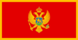 | 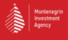 | 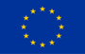

CALL FOR EXPRESSION OF INTEREST – HIGH-LEVEL INVESTMENT CONFERENCE
Smart Growth, Green Future: Accelerating Investment in Montenegro

The Chedi, Luštica Bay

14 – 15 October 2025

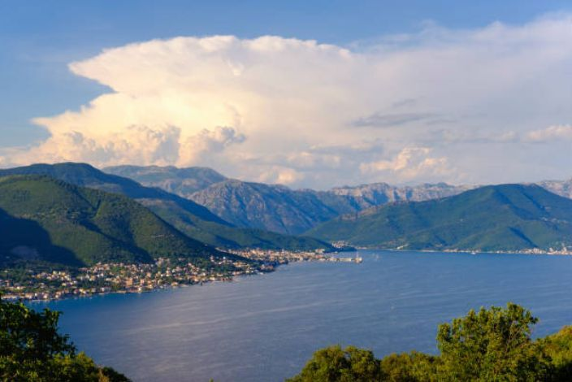
Dear Colleagues, dear Partners,
Join us for a high-level investment conference to accelerate green, sustainable and value-added investment in Montenegro, focusing on renewable energy, sustainable agribusiness, tourism, transport, and information technology. Positioned within the broader context of Montenegro’s path toward EU accession, the event seeks to strengthen the country’s role as a regional hub for green and digital investment in the Western Balkans.
The event will bring together Milojko Spajić, Prime Minister of Montenegro, senior representatives from the European Commission, and leaders from international organisations and companies across Europe. We will explore strategic investment opportunities in Montenegro, advance regulatory reforms, and build impactful partnerships. A particular focus will be placed on investments that align with the EU Green Deal, sustainable development goals, and Montenegro’s integration into the European single market.
Spaces for this exclusive conference are limited. If you are interested to participate you may apply by clicking here.
For any further questions related to the conference you may write to contact@aimconference2025.org.
We look forward to your engagement in shaping a future-ready, inclusive, and innovative economy for Montenegro and the Western Balkans.

